**WEST YORKSHIRE FIRE & RESCUE SERVICE**

# JOB DESCRIPTION

|  |  |
| --- | --- |
| **POST TITLE:** | PowerApp Developer |
| **GRADE:** | Grade 7 |
| **RESPONSIBLE TO:** | Digital Systems and Intelligence Manager ICT Services. |
|  |  |
| **PURPOSE OF POST:** | Responsible for designing, developing, and implementing custom PowerApps solutions to enhance our business processes. As a Developer, you will collaborate with cross-functional teams, understand business requirements, and leverage your expertise in Microsoft Power Platform to create efficient and user-friendly applications. |

**ORG CHART**

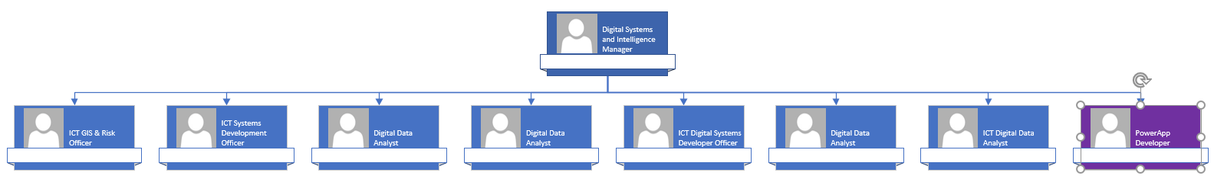

##### MAIN DUTIES AND RESPONSIBILITIES OF THE ROLE

1. **Solution Design and Development (SFIA: Solution Development, Level 5).**
   * Analyse business requirements and design custom PowerApps solutions to meet organisational needs.
   * Develop and implement efficient and scalable PowerApps applications, ensuring adherence to best practices.
   * Develop ad-hoc applications as required outside of the Power Platform to fullfil a specific Business need.
2. **Power Platform Expertise (SFIA: Solution Development, Level 5).**
   * Leverage advanced features of the Microsoft Power Platform, including Power Apps, Power Automate, and Power BI, to create comprehensive solutions.
   * Stay abreast of the latest Power Platform updates and continuously enhance skills to maximise the platform's capabilities.
3. **Collaboration (SFIA: Collaboration and Operation, Level 4).**
   * Work closely with business analysts, project managers, and end-users to gather requirements and ensure successful implementation of PowerApps solutions.
   * Collaborate with other developers and IT teams to integrate PowerApps with existing systems and applications.
4. **Testing and Quality Assurance (SFIA: Testing, Level 4).**
   * Conduct thorough testing of PowerApps solutions to identify and address bugs, ensuring a high level of quality.
   * Implement testing methodologies and maintain documentation to support application reliability.
5. **User Training and Support (SFIA: Learning and Development, Level 3).**
   * Provide training sessions for end-users on how to effectively use PowerApps applications.
   * Offer ongoing support and troubleshooting to address user queries and issues.
6. **Security and Compliance (SFIA: Information Security, Level 4).**
   * Implement security measures to safeguard PowerApps solutions and ensure compliance with organizational policies and standards.
   * Stay informed about security best practices and apply them to protect sensitive data.

**ORGANISATIONAL WIDE RESPONSBILITIES:**

1. Adherence to the Core Code which sets out five ethical principles, based on the Seven Principles of Public Life.

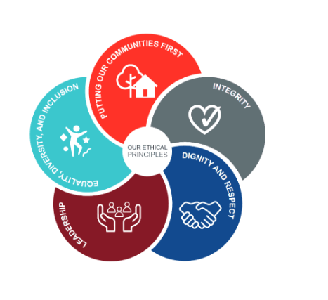

1. To Implement and promote the Authority’s:
2. Health and Safety policies.
3. Equality and Diversity policies.
4. Information Security Management System policies.
5. Safeguarding policies.
6. Business continuity policy and contingency arrangements.
7. Policies related to General Data Protection Regulation and Data Protection Act 2018.
8. Commitment to maintaining our Customer Service expectations.

**SKILLS AND EXPERIENCE REQUIREMENTS FOR THIS ROLE.**

|  |  |  |  |
| --- | --- | --- | --- |
|  | **Experience.** | **Essential/ Desirable.** | **Where Identified.** |
|  | Proven experience in PowerApps development and implementation. | Essential. | Application / interview. |
|  | Strong proficiency in Microsoft Power Platform components, including Power Apps, Power Automate, and Power BI. | Essential. | Application / interview. |
|  | Solid understanding of software development lifecycle and agile methodologies. | Essential. | Application / interview. |

|  |  |  |  |
| --- | --- | --- | --- |
|  | **Education and Training.** | **Essential/ Desirable** | **Where Identified.** |
|  | Microsoft Power Platform App Maker (PL-100) or willingness to work towards | Essential. | Application. |
|  | Power Platform Functional Consultant (PL-200) or willingness to work towards | Essential. | Application. |
|  | Microsoft Power Platform Developer (PL-400) or willingness to work towards | Essential. | Application. |

|  |  |  |  |
| --- | --- | --- | --- |
|  | **Special Knowledge and Skills.** | **Essential/ Desirable.** | **Where Identified.** |
|  | Excellent problem-solving and analytical skills. | Essential. | Interview. |
|  | Effective communication and collaboration abilities. | Essential. | Interview. |
|  | As a candidate, you should have development experience that includes Microsoft Power Platform services, JavaScript or TypeScript, JSON, and HTML front ends. | Essential. | Application / interview. |
|  | The following skills would be beneficial to the role - PowerApps Formula Language (PowerFx), C#, .NET, SQL, RESTful APIs, Microsoft Azure deployment, and CSS, PowerShell, GitHub or other Version Control Systems | Desirable. | Application / interview. |

**Job Description: Last updated: February 2024**