WEST YORKSHIRE FIRE & RESCUE SERVICE

JOB DESCRIPTION.

POST TITLE: | PAIT Administrator.
GRADE: | Grade 3.
RESPONSIBLE TO: | Prevention Partnership & Training Manager.
PURPOSE OF POST: | To provide comprehensive administrative support for the Fire Prevention Department.
ORG CHART
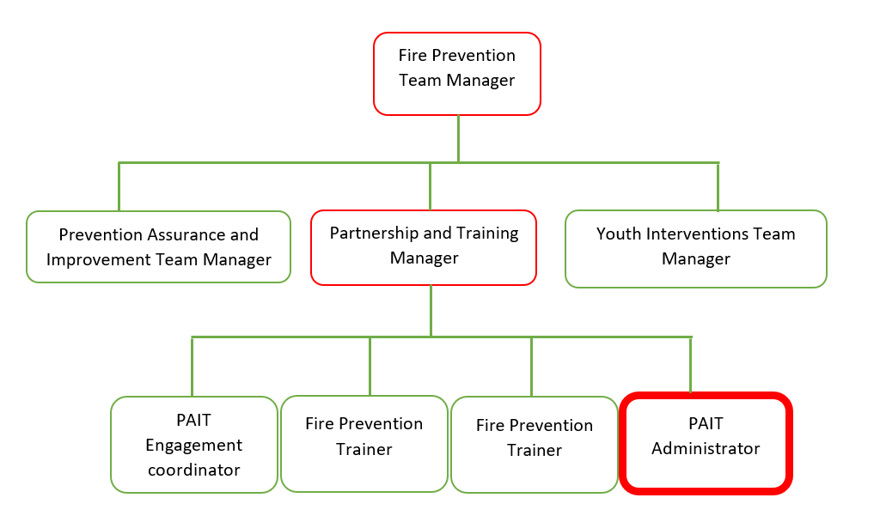

MAIN DUTIES AND RESPONSIBILITIES OF THE ROLE.

- Dealing with written, email and telephone correspondence on behalf of the Prevention Department.
- Planning meeting schedules, including preparation of documentation, data collation and maintenance of meeting records.
- Administer the Fire Prevention Department Homepage on Microsoft Teams ensuring that it remains current and relevant.
- Prevention stock management and monitoring of Prevention Department budget.
- Provide administrative support to colleagues across the organisation in delivery of their prevention duties.

ORGANISATIONAL WIDE RESPONSBILITIES:

- Adherence to the Core Code which sets out five ethical principles, based on the Seven Principles of Public Life.


- To Implement and promote the Authority’s:
- Health and Safety policies.
- Equality and Diversity policies.
- Information Security Management System policies.
- Safeguarding policies.
- Business continuity policy and contingency arrangements.
- Policies related to General Data Protection Regulation and Data Protection Act 2018.
- Commitment to maintaining our Customer Service expectations.

SKILLS AND EXPERIENCE REQUIREMENTS FOR THIS ROLE.

 | Experience. | Essential/ Desirable. | Where Identified.
 | Previous experience of office administration. | Essential. | Application / Interview.
 | Ability to communicate effectively through verbal and written means at all levels, including internal staff, partner organisations, members of the public and community groups. | Essential. | Application / Interview.
 | Demonstrate an ability to work independently and as part of a team, having commitment and flexibility in working hours to meet objectives. | Essential. | Application / Interview.

 | Education and Training. | Essential/ Desirable | Where Identified.
 | Word Processing at RSA/OCR 2 or equivalent. | Desirable. | Application.
 | Good level of Numeracy and Literacy. | Essential. | Application.

 | Special Knowledge and Skills. | Essential/ Desirable. | Where Identified.
 | Be self-motivated, organized and able to prioritise work to set deadlines with minimal supervision. | Essential. | Application and Selection process.
 | Demonstrate effective use of IT systems such as Microsoft Office, Word, Outlook, Teams and Excel. | Essential. | Application and Selection process.
 | Demonstrate commitment to good data quality within all areas of work, knowledge of confidentiality issues and compliance with General Data Protection Regulations | Essential. | Application and Selection process.
 | An understanding of and commitment to diversity and inclusion. | Essential. | Interview.
 | To hold and maintain a current full UK valid car driving licence. | Desirable | Application.

Job Description: Last updated: March 2024 [New JD Template].
[Prior to Grade Assimilation in 2019 was Grade 3, Grade 2 from 1 April 2019, Job Evaluation – regraded to Grade 3 under grading system in use up to 2022].

