WEST YORKSHIRE FIRE & RESCUE SERVICE

JOB DESCRIPTION

POST TITLE: | Multimedia Administrator
GRADE: | Grade 2
RESPONSIBLE TO: | Multimedia Supervisor
PURPOSE OF POST: | Provide comprehensive administrative support to the Multimedia and Training and Development teams. Support the process the Authority’s ‘Silent Witness’ CCTV footage.
ORG CHART

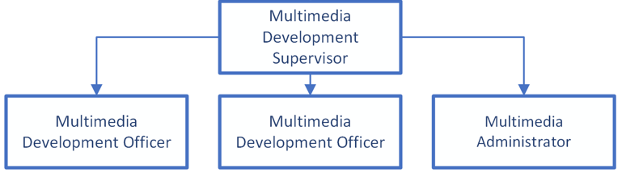

MAIN DUTIES AND RESPONSIBILITIES OF THE ROLE

- Provide clerical and administrative support to the Multimedia and Training and Development teams.
- Manage the Authority’s ID card system, including production and maintenance.
- Support the process and handling of the Authority’s ‘Silent Witness’ CCTV footage, ensuring it is recorded, handled, and made available for Police / Fire Investigation purposes and other Authority requirements.
- Assist with the upkeep and logging of the video library, including Silent Witness footage.
- Awareness of photography and imaging / video production equipment.
- Maintain and assist with the upkeep of all multimedia equipment, both mobile and static.
- Utilise IT systems to produce Training Centre documentation.
- Input data into computer systems, ensuring accuracy and data quality.
- Participate in all training activities as directed by the Multimedia Supervisor.
- Commit to and understand the Authority’s Equality & Diversity, Health and Safety, and Information Security Management System policies.
- Perform any other duties as directed by the Multimedia Supervisor that are commensurate with the post.

ORGANISATIONAL WIDE RESPONSBILITIES:

- Adherence to the Core Code which sets out five ethical principles, based on the Seven Principles of Public Life.


- To Implement and promote the Authority’s:
- Health and Safety policies.
- Equality and Diversity policies.
- Information Security Management System policies.
- Safeguarding policies.
- Business continuity policy and contingency arrangements.
- Policies related to General Data Protection Regulation and Data Protection Act 2018 .
- Commitment to maintaining our Customer Service expectations.

SKILLS AND EXPERIENCE REQUIREMENTS FOR THIS ROLE.

In the supporting statement section of the application form give clear, concise examples of how you meet all of the Essential person specification criteria (i.e. items you must be able to do from day one to be able to do the job), identified as ‘Application’ in order to be shortlisted for this vacancy. If a large number of applications are received, only those who also meet the Desirable criteria, identified as ‘Application’, will be shortlisted, i.e. criteria you need to do the job, but which could be learnt during training.

Please list or number the competency criteria below against which you are providing evidence/examples in order to structure your supporting statement in a well organised way.

There may be some criteria that are identified through ‘Selection Process’ only. You will only be assessed on these criteria during the selection process and not from your application form, this may involve tests, presentations, interview etc.

 | Experience. | Essential/ Desirable. | Where Identified.
 | Administrative experience in an office environment | Essential | Application form & Selection Process
 | Knowledge and ability to use computer office systems | Essential | Application form & Selection Process

 | Education and Training. | Essential/ Desirable | Where Identified.
 | Must be numerate and literate | Essential | Application form & Selection Process

 | Special Knowledge and Skills. | Essential/ Desirable. | Where Identified.
 | Understanding of photography and imaging / video production equipment | Desirable | Application form & Selection Process
 | Good communication skills, both verbal and written | Essential | Application form & Selection Process
 | Ability to deal with sensitive and confidential material | Essential | Application form & Selection Process
 | Understanding the importance of equality and diversity to WYFRS as an employer and service provider | Essential | Selection Process
 | Commitment to good data quality within all areas of work | Essential | Selection Process

Job Description: Last updated: 03/10/2024

