**WEST YORKSHIRE FIRE & RESCUE SERVICE.**

# JOB DESCRIPTION.

|  |  |
| --- | --- |
| **POST TITLE:** | Purchasing Officer |
| **GRADE:** | 5 |
| **RESPONSIBLE TO:** | Stores Manager |
|  |  |
| **PURPOSE OF POST:** | To ensure that goods and services are procured on behalf of operational and support departments in a timely and efficient manner, adhering to the principles of best value and contract procurement rules. |

**ORG CHART.**

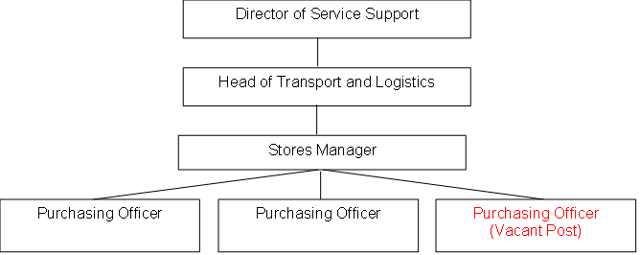

##### MAIN DUTIES AND RESPONSIBILITIES OF THE ROLE.

1. Establish the requirements of internal customers and other stakeholders for the buying of supplies and services, maintaining excellent customer service and effective stakeholder relationships with customers and suppliers.
2. Ensure compliance with organisational procedures including contract procedure rules and financial regulations when sourcing products. Check that contracts and framework agreements remain valid before placing orders and ensure that the correct goods and pricing match the original quote / order, representing best value in procurement.
3. Operate and promote the use of electronic purchasing systems for requisitioning, ordering and invoicing and ensure stock levels are monitored and maintained against manufacturer lead times.
4. Identify sourcing and supply chain problems and work to develop solutions, ensuring timely and sustainable corrective actions are applied.
5. Provide training to department staff on the electronic ordering system, procurement procedures and ordering processes.

**ORGANISATIONAL WIDE RESPONSIBILITIES:**

1. Adherence to the [NFCC Core Code of Ethics](https://nfcc.org.uk/our-services/people-programme/core-code-of-ethics/%20Services%20England.pdf) and [West Yorkshire Fire Service Values](https://www.westyorksfire.gov.uk/sites/default/files/2023-03/WYFRS%20Core%20Values%20June22.pdf).

[](https://nfcc.org.uk/our-services/people-programme/core-code-of-ethics/%20Services%20England.pdf)

1. To Implement and promote the Authority’s:
2. Health and Safety policies.
3. Equality and Diversity policies.
4. Information Security Management System policies.
5. Safeguarding policies.
6. Business continuity policy and contingency arrangements.
7. Policies related to General Data Protection Regulation and Data Protection Act 2018.
8. Commitment to maintaining our Customer Service expectations.
9. A satisfactory standard/enhancedDisclosure and Barring check is required for the role.
10. This post has been designated a hybrid working post which means the postholder’s working time can be split between the workplace and home.  The actual working pattern and number of days at each will be agreed locally with the line manager and will be determined based on the service needs.

**SKILLS AND EXPERIENCE REQUIREMENTS FOR THIS ROLE.**

In the supporting statement section of the application form give clear, concise examples of how **you meet all of the Essential person specification criteria** (i.e. items you must be able to do from day one to be able to do the job), **identified as ‘Application’ in order to be shortlisted for this vacancy**. If a large number of applications are received, only those who also meet the Desirable criteria, identified as ‘Application’, will be shortlisted, i.e. criteria you need to do the job, but which could be learnt during training.

Please list or number the competency criteria below against which you are providing evidence/examples in order to structure your supporting statement in a well organised way.

There may be some criteria that are identified through ‘Selection Process’ only. **You will only be assessed on these criteria during the selection process and not from your application form**, this may involve tests, presentations, interview etc.

|  |  |  |  |
| --- | --- | --- | --- |
|  | **Experience.** | **Essential/ Desirable.** | **Where Identified.** |
|  | Demonstrable knowledge/experience of general sourcing and buying of goods or services in a business setting. | Essential | Application & Selection Process. |
|  | Workplace experience of the input and maintenance and retrieval of information utilising Microsoft word and excel. | Essential | Application & Selection Process. |
|  | Experience of electronic purchase / stock management applications. | Desirable | Application & Selection process |

|  |  |  |  |
| --- | --- | --- | --- |
|  | **Education and Training.** | **Essential/ Desirable.** | **Where Identified.** |
|  | Literacy and Numeracy at Level 2 / GCSE Maths and English (Grade C or above) / equivalent qualifications, or equivalent level of literacy and numeracy gained through work experience. | Essential | Application |
|  | Diploma Member of Chartered Institute of Purchasing and Supply (CIPS) (or committed to achieve). | Desirable | Application |

|  |  |  |  |
| --- | --- | --- | --- |
|  | **Special Knowledge and Skills.** | **Essential/ Desirable.** | **Where Identified.** |
|  | Demonstrate knowledge, understanding and capabilities of sourcing and buying to achieve value for money. | Essential | Application & Selection Process |
|  | Good understanding of the legislative framework that regulates public sector procurement. | Desirable | Application & Selection Process |
|  | Develop a good understanding of WYFRA Contract Procedure Rules and Financial Regulations | Desirable | Application & Selection Process |
|  | Demonstrate commitment to good data quality within all areas of work. | Essential | Selection Process Only |
|  | Demonstrate commitment to and understanding of the importance of Equality & Diversity, NFCC Core Code of Ethics and WYFRS values | Essential | Selection Process Only |
|  | Ability to plan and prioritize based on workload, organizational need and external pressures. | Essential | Application & Selection Process |
|  | To hold and maintain a current full UK valid car driving licence | Essential | Application & Selection Process |

Job Description: Last updated: 13/08/2024