**WEST YORKSHIRE FIRE & RESCUE SERVICE**

# JOB DESCRIPTION

|  |  |
| --- | --- |
| **POST TITLE:** | Vehicle Team Assistant |
| **GRADE:** | 2 |
| **RESPONSIBLE TO:** | Workshop Manager |
|  |  |
| **PURPOSE OF POST:** | To provide manual handling, driving and light clerical support to the workshop and fleet management teams. |

**ORG CHART**

##### MAIN DUTIES AND RESPONSIBILITIES OF THE ROLE

1. Move authority vehicles for service and repair to any WYFRS or external contractor site on behalf of workshops and fleet management teams.
2. Assist the fleet management team with daily and weekly vehicle checks, ensuring that vehicles are cleaned and fuelled, and remain in good condition.
3. Ensure the cleanliness of our workshop and promote good engineering hygiene, carry out vehicle cleaning (pressure washing) prior to workshop repair.
4. Replenish bulk oil containers and assist Workshop Chargehands in managing oil / fuel stocks.
5. Comply with our Transport Health & Safety Policy, ensuring that all duties and responsibilities are completed safely, using correct tools and PPE at all times.
6. Undertake any other training and duties commensurate with the post as directed by the Workshop Manager.

**ORGANISATIONAL WIDE RESPONSIBILITIES:**

1. Adherence to the [NFCC Core Code of Ethics](https://nfcc.org.uk/our-services/people-programme/core-code-of-ethics/%20Services%20England.pdf) and [West Yorkshire Fire Service Values](https://www.westyorksfire.gov.uk/sites/default/files/2023-03/WYFRS%20Core%20Values%20June22.pdf).

[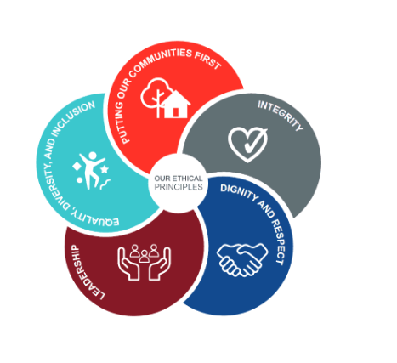](https://nfcc.org.uk/our-services/people-programme/core-code-of-ethics/%20Services%20England.pdf)

1. To Implement and promote the Authority’s:
2. Health and Safety policies.
3. Equality and Diversity policies.
4. Information Security Management System policies.
5. Safeguarding policies.
6. Business continuity policy and contingency arrangements.
7. Policies related to General Data Protection Regulation and Data Protection Act 2018.
8. Commitment to maintaining our Customer Service expectations.
9. A satisfactory Standard Disclosure and Barring check is required for the role.

**SKILLS AND EXPERIENCE REQUIREMENTS FOR THIS ROLE.**

In the supporting statement section of the application form give clear, concise examples of how **you meet all of the Essential person specification criteria** (i.e. items you must be able to do from day one to be able to do the job), **identified as ‘Application’ in order to be shortlisted for this vacancy**. If a large number of applications are received, only those who also meet the Desirable criteria, identified as ‘Application’, will be shortlisted, i.e. criteria you need to do the job, but which could be learnt during training.

Please list or number the competency criteria below against which you are providing evidence/examples in order to structure your supporting statement in a well organised way.

There may be some criteria that are identified through ‘Selection Process’ only. **You will only be assessed on these criteria during the selection process and not from your application form**, this may involve tests, presentations, interview etc.

|  |  |  |  |
| --- | --- | --- | --- |
|  | **Experience.** | **Essential/ Desirable.** | **Where Identified.** |
|  | Experience working in a commercial vehicle environment | Desirable | Application and Selection process |
|  | Geographical knowledge of West Yorkshire | Desirable | Application and Selection process |
|  | Driving large vehicles up to 26 tonnes, cars and vans up to 5 tonnes | Essential | Application and Selection process |

|  |  |  |  |
| --- | --- | --- | --- |
|  | **Education and Training.** | **Essential/ Desirable** | **Where Identified.** |
|  | Literate and numerate | Essential | Application |
|  | Have and maintain a class C driving licence entitlement | Essential | Application |

|  |  |  |  |
| --- | --- | --- | --- |
|  | **Special Knowledge and Skills.** | **Essential/ Desirable.** | **Where Identified.** |
|  | An ability to plan own workload and driving routes | Essential | Application and Selection process |
|  | Work independently and as an effective member of the team | Essential | Application and Selection process |
|  | Work flexibly where the needs of the role can change at short notice | Essential | Application and Selection process |
|  | Demonstrate commitment to and understanding of Equality & Diversity, NFCC Core Code of Ethics and WYFRS values | Essential | Selection process only |

**Pilat and Job Description: Last updated: 09/07/2024**