WEST YORKSHIRE FIRE & RESCUE SERVICE

JOB DESCRIPTION

POST TITLE: Fire Prevention Officer

GRADE: Grade 3

RESPONSIBLE TO: District Prevention Manager

PURPOSE OF POST: To provide community safety advice and conduct high risk interventions.

ORGANISATIONAL CHART

MAIN DUTIES AND RESPONSIBILITIES OF THE ROLE

- To reduce the fire related fatalities and injuries in West Yorkshire by conducting high risk interventions and safe and well visits.

- Delivering prevention education and community engagement activities.

- To attend multi-agency case meetings regarding high-risk individuals, to provide information, expert advice and support.

- To organise, manage and deliver district-based safety events as directed by the District Prevention Manager or Prevention Assurance and Improvement Team Manager ensuring the safe and appropriate use of resources.

- To support station colleagues in prevention activities.

ORGANISATIONAL WIDE RESPONSIBILITIES:

- Adherence to the Core Code which sets out five ethical principles, based on the Seven Principles of Public Life.
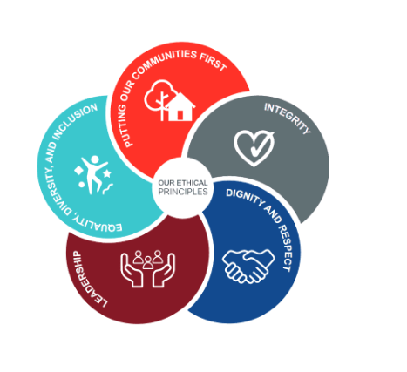

- To Implement and promote the Authority’s:
- Health and Safety policies.
- Equality and Diversity policies.
- Information Security Management System policies.
- Safeguarding policies.
- Business continuity policy and contingency arrangements.
- Policies related to General Data Protection Regulation and Data Protection Act 2018.
- Commitment to maintaining our Customer Service expectations.

- A satisfactory enhanced Disclosure and Barring check is required for the role.

SKILLS AND EXPERIENCE REQUIREMENTS FOR THIS ROLE.

In the supporting statement section of the application form give clear, concise examples of how you meet all of the Essential person specification criteria (i.e. items you must be able to do from day one to be able to do the job), identified as ‘Application’ in order to be shortlisted for this vacancy. If a large number of applications are received, only those who also meet the Desirable criteria, identified as ‘Application’, will be shortlisted, i.e. criteria you need to do the job, but which could be learnt during training.

Please list or number the competency criteria below against which you are providing evidence/examples in order to structure your supporting statement in a well organised way.

There may be some criteria that are identified through ‘Selection Process’ only. You will only be assessed on these criteria during the selection process and not from your application form, this may involve tests, presentations, interview etc.

 | Experience. | Essential/ Desirable. | Where Identified.
 | Ability to communicate effectively with members of partner organisations, members of the public, identified at risk individuals and community groups. | Essential | Application and Selection process
 | Experience in the delivery of education, awareness and training in the community. | Essential | Application and Selection process
 | Demonstrate an ability to work independently and as part of a team, having commitment and flexibility in working hours to meet objectives. | Essential | Application and Selection process

 | Education and Training. | Essential/ Desirable | Where Identified.
 | A good standard of written and verbal communication. | Essential | Application and Selection process

 | Special Knowledge and Skills. | Essential/ Desirable. | Where Identified.
 | Be self-motivated and prioritise work directed to set targets with minimal supervision. | Essential | Application and Selection process
 | Have an understanding of the social and environmental issues affecting different communities, with particular reference to issues of high risk and vulnerability. | Desirable | Application and Selection process
 | Confident use of IT systems such as Microsoft Word, PowerPoint, Teams and Excel. | Essential | Application and Selection process
 | Demonstrate an understanding of the importance of equality and diversity to WYFRS as an employer and service provider. | Essential | Selection Process
 | To hold and maintain a current valid driving licence. | Essential. | Application.

Job Description: Last updated: January 2024.

