Firework and Bonfire Safety

Year 4

Delivery Session Plan

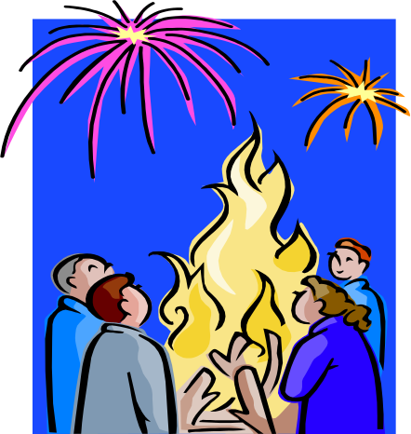

Year 4 Pack Contents

Page 2 | Pack contents
Page 3 | Introduction
Page 4 | Activity 1
Page 5 | Activity 1 - Hazard Spotting Colouring Sheet
Page 6 | Activity 1 – Teacher Discussion Points
Page 7 - 8 | Activity 2
Page 9 | Activity 3
Page 10 - 14 | Fire Safety – Teacher Information Sheets
Page 12 | Fire Safety – Top Tips
Page 13 | The Firework Code
Page 14 | Fireworks and the Law/Useful websites
Page 15 | Evaluation Information
Page 16 | Teacher Reflection and Feedback Form
Page 17 | Pupil Reflection and Feedback Form

Introduction

West Yorkshire Fire and Rescue Service aims to provide safety awareness education to the communities of West Yorkshire through a variety of means.

This school pack is aimed at Year 4 pupils within school and encourages children’s raised awareness of issues related to the Bonfire Night period, whilst incorporating important fire safety messages appropriate to any time of year. Staff from the Fire Service will continue to make school visits to pupils within schools to speak to young people on a range of fire related safety topics, but session packs for Years 4, 6 and 8 are now available for teacher delivery within their individual school timetable when possible, particularly suitable for use in the lead up to Bonfire Night.

A suite of products that compliment previous work carried out by West Yorkshire Fire and Rescue Service when educating and informing young people on Bonfire and Firework safety has now been developed. Presentations have been created to target pupils on age related topics relevant to the Bonfire period and are delivered by either a member of staff from West Yorkshire Fire and Rescue Service or by teachers within the school.

Organisations such as the Department of Trade and Industry (DTI) have produced a range of interesting resources for use in schools in relation to Fireworks, and the information contained in this session pack compliments such existing resources for use in schools.

For more information on downloadable educational school packs from DTI please see:

www.dti.gov.uk/fireworks

Recommendations:

- We suggest that these Year 4 sessions are scheduled to take place in the week prior to the 5th November (Bonfire Night)

- The activities contained within this booklet can be incorporated into your existing school timetable to compliment any work being undertaken by teachers near the Bonfire period

- Activity One and Two can be used as a stand alone lesson plan to cover important safety messages particularly relevant at this time of year

- We recommend Activity Three is allocated the same time as a typical lesson within school (for example 50-60 minutes). As this lesson focuses on the use and practice of literacy skills it may also be ideally suited to an English lesson

- Refer to Teacher Information Sheets (Pages 11 – 15) at the back of this booklet before using the various activities with pupils as a reminder of the key safety messages for discussion

Activity One

Hazard Spotting Colouring Sheet

Task:

- Pupils should work in small groups to identify any hazards from the worksheet and discuss the particular dangers from each hazard (suggested time 10 mins)

- Pupils to work individually on colouring in the worksheet (suggested time 20 mins)

- The colouring sheet should be used as a starting point for the class based activities within this session pack and used to demonstrate understanding of the class discussion surrounding bonfire and firework safety.

See next page for worksheet for photocopying to accommodate the number of pupils in the class

Aims and Objectives:

The colouring sheet encourages children to identify potential hazards at a bonfire party. The children should be encouraged to openly discuss the risks that are highlighted on the worksheet and suggest how these may be avoided.

The worksheet aims to encourage the children to think of their own risk management techniques that could be adapted to their own life and the type of event they may attend.

Guidance:

- Please see Teacher Discussion Point sheet (page 6) for suggestions in encouraging class discussion and a list of the issues that can be identified in the Hazard Spotting Colouring Sheet.

Please note:

Sheets can be photocopied to accommodate different class sizes and enlarged for use with pupils who may be visually impaired.

Alternatively the sheet could be issued as a homework activity to compliment any existing work being carried out in school during the bonfire period. Pupils should be encouraged to complete this with the supervision of a parent/guardian or family member and discuss issues related to bonfire safety to strengthen the key messages they have learned in school.

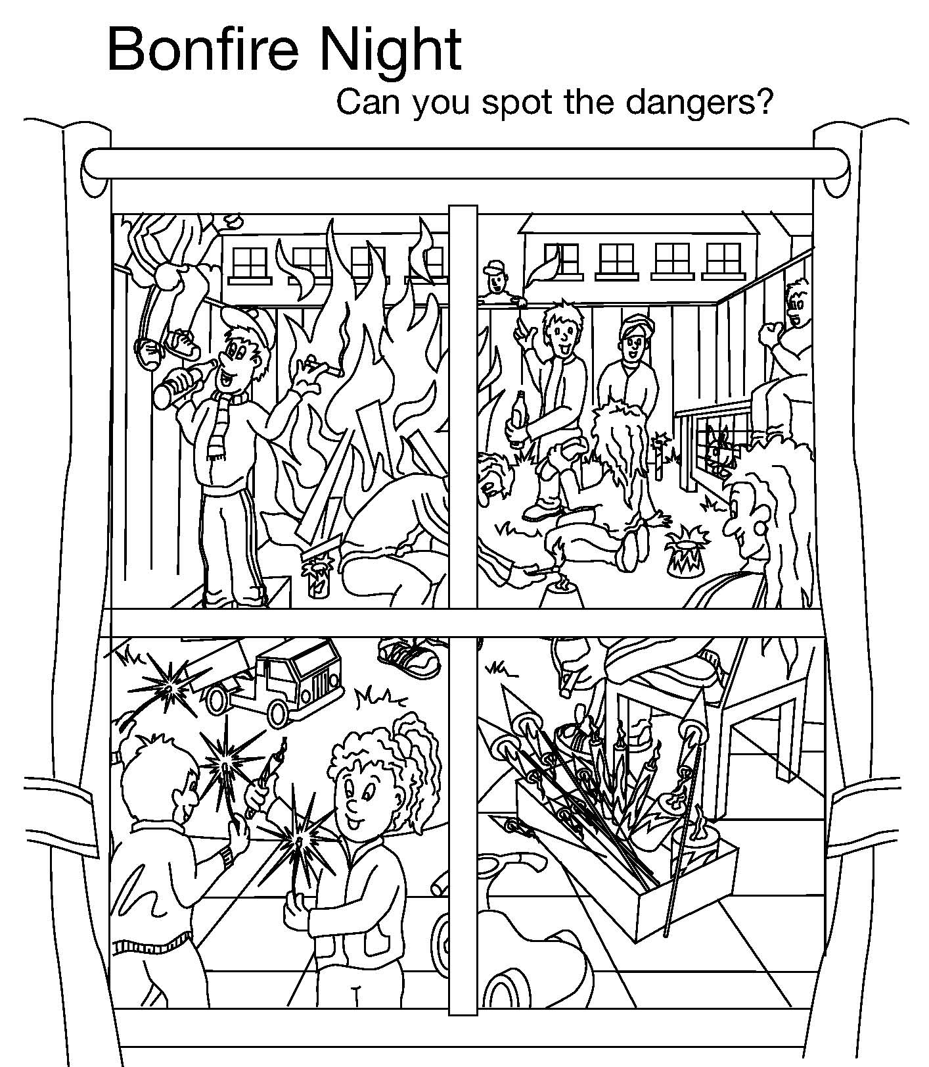
Hazard Spotting Work Sheet

Teacher Discussion Points

Pupils should be able to identify some of the following hazards:

- children playing with fireworks unsupervised
- small children with sparklers unsupervised
- wheeled toy behind children (trip hazard)
- toys scattered on the ground (trip hazards)
- teenagers drinking
- people smoking cigarettes near fireworks
- someone sitting on the fence dangerously close to the fire
- people wearing tracksuit bottoms and other types of inappropriate clothing for attending a bonfire
- fireworks that may/may not have been lit scattered around the garden
- bonfire built too near the fence
- girl sat on the ground near to a firework
- rabbit in the hutch near the bonfire
- man in the middle of the chaos lighting a firework with a naked flame
- woman sitting near a box of fireworks with a cigarette
- fireworks not stored in safe, tin container/box
- generally chaotic with lots of distractions

Discussion points could include:

- encourage pupils to think about the dangers of people drinking alcohol when attending or supervising at bonfires, especially people responsible for lighting the fireworks
- safe storage of fireworks – for example, out of the reach of children in a tin box or container that is stored in a cool, dry place
- dangers of children holding fireworks and sparklers
- dangers of building a bonfire too close to the fence, and the risk of setting fire to the property of others or buildings close by
- dangers of cigarettes too close to unlit fireworks
- where ideally should the rabbit be? For example, left in the house or garage away from the loud noises and the smoke from the fire
- possible risks of wearing inappropriate clothing, and the risks of the fabric melting and setting on fire if too close to the fire or near sparks from fireworks

Activity Two

Art Based Activity



Task:

- Pupils to produce a piece of art work (based on the hazards discussed in Activity One and whilst completing the colouring sheet) using a variety of media to highlight some of the key safety messages that are relevant to bonfire and firework safety
- Pupils should be encouraged to produce a piece of work that identifies considerations of important safety themes
- Volunteers can be asked to showcase their work to the group at the end of the session and explain the key messages they have chosen to incorporate.

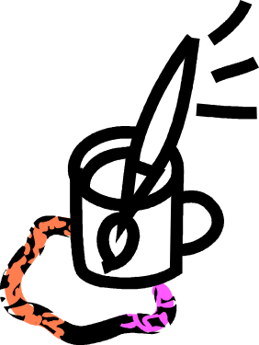

Aims and Objectives:

- Pupils to demonstrate their learning and understanding of the bonfire and firework safety information that they discussed with the teacher at the beginning of the session when participating in Activity One – Hazard Spotting Colouring Sheet
- Pupils to create an imaginative piece of art work and practicing composition skills, whilst exploring their ideas with a range of media.

Discussion points:

What key safety messages does the art work highlight?
Does the art work aim to prevent this type of danger?
Does the art work clearly show the consequences of this risky behaviour?
Why have the materials used been chosen? What effect does this give?

Resources:

Each pupil will need a piece of paper or card (either A4 or A3 in size)

Possible materials that could be used:

- Paint
- Pencil
- Newspaper cuttings
- Collage materials
- Pastel
- Charcoal
- Graphite

This activity could be incorporated into an existing art lesson prior to the 5th November or used as a separate lesson in the lead up to Bonfire Night.
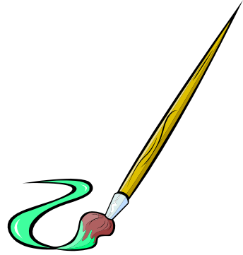

Activity Three

Diary Extract – Written piece


Task:

- Pupils to produce a written piece of work about a bonfire that they have attended or plan to attend – this should be in the form of a diary entry
- Pupils should be encouraged to use descriptive language
- If pupils have never attended a bonfire they should write an account of the types of things they think would happen and possibly the kinds of fireworks they might expect to see or they may have seen a bonfire on TV that they could refer to
- Volunteers could be asked to share their work with the class at the end of the session

Suggested time for this activity would ideally be 50-60 minutes

Aims and Objectives:

- Pupils to demonstrate their learning and understanding in written form
- Encourages the use of literacy and communication skills
- Pupils are encouraged to read aloud and share their thoughts and ideas with the group to prompt discussion

Discussion points:

- What types of safety measures were/are in place?
- What might happen if these safety measures were ignored? Consequences?
- Who did they attend the bonfire with?
- Description of the fire, fireworks and the other people who were present
- Was the bonfire fun and enjoyable?
- What other forms of entertainment were there?
- Was it a family bonfire or an organised event?

Resources:
Each pupil will need:

- Workbooks or sheets of lined paper
- Pencil or pen

This activity could be incorporated into an existing English lesson prior to the 5th November or used as a separate lesson in the lead up to Bonfire Night.

Fire Safety - Teacher Information Sheets

You may find it useful to refer to the following information when discussing with the young people in your class some of the various issues relevant to keeping safe around the bonfire period. The following pages contain brief information on:

- Fire Safety Top Tips

- The Fireworks Code

- Fireworks and the Law

- Useful websites for reference

Fire Safety – Top Tips!



Children should be reminded of the following top tips – and remind their parents or guardians!

- Don’t over stack bonfires or make them too large to control
- Check the fire before lighting (ensuring there are no animals or small children hiding inside)
- Never light a bonfire too early – it can soon get out of control
- Never light a bonfire that doesn’t belong to you
- Never put fireworks on a bonfire
- Never burn dangerous rubbish – such as aerosols or paint tins
- Make sure spectators stand well back to prevent flying embers catching alight on clothing
- When the bonfire is over, the fire needs to be put out completely – don’t leave it smouldering as it could catch light again

- Light sparklers one at a time and always wear gloves
- Never give a sparkler to a child under the age of five – they will not understand how to use them safely
- Children should be supervised when using sparklers
- When the sparkler has finished, plunge it into a bucket of water with the hot end down as they can stay hot for a long time
- Store sparklers in a closed tin box in a cool dry place
- Avoid wearing inappropriate clothing such as loose, flowing clothing that could potentially catch light

REMEMBER THE FIREWORK CODE

The Firework Code

- Stand well back

- Never go back to a lit firework

- Never put fireworks in your pocket

- Never throw fireworks

- Light sparklers one at a time and wear gloves

- Never give sparklers to a child under five

- Keep pets indoors

More specifically for adults . . .

- Only buy fireworks marked BS 7114
- Keep fireworks in a closed tin box
- Follow individual instructions on each firework
- Light fireworks at arms length using a taper

Fireworks and the Law

Curfew on fireworks:

The Noise Act specifies that fireworks cannot be used between the hours of 11pm and 7am, with the exception of the following dates where the times may vary:

- November 5th – until midnight
- New Years Eve – 1am on the following day
- Diwali – 1am on the following day
- Chinese New Year - 1am on the following day

Fireworks – the law:

- Under 18s are not permitted to purchase fireworks or to possess them in a public place

Fireworks – the retailer’s responsibility:

- Fireworks are an age restricted product and should be treated in the same way as other such products, for example, alcohol or cigarettes
- Retailers can face hefty fines for selling fireworks to anybody under the age of 18

Useful advice:

- Only buy fireworks marked BS 7114
- Illegal fireworks are often sold cheaply, however the quality cannot be assured

Discussion Points:

- Reminder that from the age of 10 you are criminally responsible for your actions and can be punished accordingly by Police/Criminal Justice System
- Why do pupils think there are age restrictions placed on certain products such as fireworks? Do they agree with this?
- Why are time restrictions put on the use of fireworks? For example, anti-social behaviour linking to loud noises during certain times (e.g. when people are trying to sleep).

For more information visit: www.dti.gov.uk/fireworks for schools packs aimed at Key Stage 2 pupils.

Other Useful Websites:

- www.westyorksfire.gov.uk

- www.dti.gov.uk/fireworks

- www.welephant.co.uk

Evaluation

Please help us by sparing some time to give us your comments on the activities that we have provided.

We would be very grateful if you could please access the following link to provide feedback for this resource http://www.stellarsurvey.com/s.aspx?u=22001EA2-A8A8-49EC-A475-A90BF55A98D4
or alternatively download and complete the paper based version and post back to us at the address provided.

Thank you!

